**Academy of Technology**



MODEL QUESTIONS, ODD SEMESTER 2022

**Subject: DISCRETE MATHEMATICS Subject Code: PCC-CSBS302**

**Semester- 3rd Stream-CSBS**

# **GROUP-A (Each question carries 1 marks)**

1. An edge whose two end vertices coincide is called

(a) ring (b) loop (c) adjacent edge (d) none

2. A simple graph has

(a) no parallel edges (b) no loops (c) no parallel edges and no loops (d) none

3. The degree of an isolated vertex is

(a) 0 (b) 1 (c) 2 (d) none

4. A vertex whose degree is 1 is called

(a) isolated vertex (b) pendant vertex (c) even vertex (d) none

5. The degree of the common vertex of two edges in series is

(a) 0 (b) 1 (c) 2 (d) may be more than 2

6. If a graph has 5 vertices and 7 edges then the size of the adjacency matrix is

(a) 5 × 5 (b) 5 × 7 (c) 7 × 5 (d) 7 × 7.

7. If a graph has 5 vertices and 7 edges then the size of the incidence matrix is

(a) 5 × 5 (b) 5 × 7 (c) 7 × 5 (d) 7 × 7

8. The sum of the degree of all vertices of a graph is 40. Then the number of edges is

(a) 10 (b) 20 (c) 25 (d) 40

9. The maximum degree of any vertex in a simple graph with 10 vertices is

(a) 10 (b) 5 (c) 9 (d) 20

10. The number of edges in a complete graph with n vertices is

(a) (b) (c) (d)

11. The maximum number of edges in a connected graph of 7 vertices is

(a) 6 (b) 7 (c) 21 (d) 14

12. Choose the correct one

(a) Every walk is a path (b) Every circuit is a path (c) Every loop is a circuit (d) The starting and ending vertices of a walk is always distinct

13. Which of the following is WRONG?

(a) Every graph is its own subgraph (b) a loop is a circuit (c) The vertex set of a graph cannot be null graph (d) Every regular graph is complete

15. If G be a connected planar graph with n vertices, e vertices and f regions then n – e + f =2 the statement is (a) True (b) False

17. The edge set of a null graph is

(a) Empty set (b) Single-tone set (c) Infinite set (d) None

18. The vertex set of a null graph is

(a) Empty set (b) Non-empty set (c) Singleton set (d) None

19. Every vertex of a null graph is

(a) Pendant (b) Isolated (c) Odd (d) None

20. A complete must be a

(a) Circuit (b) Regular (c) Non-simple (d) Null graph

21. The vertex set of a spanning subgraph of a graph G is

(a) Is a proper subset of the vertex set of G (b) Identical with the vertex set of G (c) May not be a subset of the vertex set of G (d) None

22. A self-loop cannot be included in a

(a) Walk (b) Path (c) Trail (d) None

25. If e be the number of edges, n be the number of vertices and k be the number of components of a graph G then

(a) $e < n – k$ (b) $e ≥n -k$ (c) (d) none

26. A minimally connected graph is a

(a) Binary tree (b) Hamiltonian graph (c) Tree (d) Regular graph

27. A graph has 15 vertices and 20 edges. The least number of edges to be removed from the graph to make it a tree is

(a) 13 (b) 5 (c) 19 (d) 6

30. A graph G has a spanning tree iff G is

(a) Regular (b) Connected (c) Simple (d) Tree

31. If we consider 25 vertices and 26 components then

(a) The graph must be null graph (b) The graph must be regular (c) The graph does not exist (d) The graph is a Euler graph

32. The maximum degree of any vertex in a simple graph with 10 vertices is

(a) 10 (b) 9 (c) 8 (d) 7

33. A simple connected graph with 8 vertices may have at most

(a) 8 edges (b) 64 edges (c) 28 edges (d) 10 edges

34. According to Euler formula we can write

$n-e+f=1$ (b) $n-e+f=2$ (c) (d) None

35. A complete graph with 10 edges has

(a) 5 vertices (b) 4 vertices (c) 6 vertices (d) 10 vertices

36. A simple connected graph with 6 vertices may have at least

(a) 6 edges (b) 4 edges (c) 5 edges (d) 7 edges

37. A simple graph with 6 vertices and 2 components has atleast

(a) 2 edges (b) 5 edges (c) 4 edges (d) 8 edges

38. The chromatic number of a TREE having "n" vertices is

(a) 1 (b) 2 (c) 3 (d) n

39. Indicate which one of the following is impossible

(a) A graph with 9 odd vertices (b) A graph with 9 even vertices (c) Sum of the degrees of all vertices in a graph is 50 (d) Number of edges of a graph is 40

40. The sum of the out-degrees of all vertices of a di-graph is 20, then the number of edges in the graph is (a) 20 (b) 40 (c) 10 (d) None

41. If all the elements of the 2nd row of an incidence matrix are 0 then the second vertex is (a) Pendant (b) Isolated (c) Odd (d) None

43. Incidence matrix of a graph is

(a) Symmetric (b) Skew symmetric (c) Singular (d) None

45. The number of pendant vertices in a binary tree with n vertices is

(a) (b) (c) (d)

46. Complete graph is always regular graph?

a) True b) False

47. Every graph is TREE?

a) True b) False

48. One of the minimal spanning tree algorithms is _____________

a) Dijkstra’s b) Prims c) Simmon’s d) None

49. A binary tree should have at least

(a) One vertex (b) Two vertices (c) Three vertices (d) Four vertices

50. The degree of the root of a binary tree is

(a) 1 (b) 3 (c) 4 (d) 2

51. v~p is a tautology

a) True b) False

52. ~p is a tautology

a) True b) False

53. p∧T =?

(a) p (b) T (c) F (d) None

54. pvF =?

(a) p (b) T (c) F (d) None

55. is a contradiction.

a) True b) False

56. The proposition p∧(~pvq) is

(a) Tautology (b) Logical equivalence to p∧q (c) Logical equivalence to pvq (d)Contradiction

57. The expression (p∧q)v(q∧r)v(r∧p)

(a) Tautology (b) Contradiction (c) None (d) Both

58. p ∧ F=?

(a) True (b) False

59. is ____________?

(a) Tautology (b) Contradiction (c) None (d) Both

60. is a contradiction

(a) True (b) False

23. Which of the following set is closed under numerical multiplication

1. {1, -1, 0, 2}
2. {1, i}
3. {1, ω, ω2}
4. {ω, 1}

24. In the group {1, ω, ω2} under numerical multiplication, order of ω is

a) 3

b) 6

c) -3

d) 9

25. If the cyclic group G contains 11 distinct elements then it has

a) two generators

b) seven generators

c) nine generators

d) ten generators

26. The only generators of the cyclic group (Z, +) is

a) 1

b) 0, 1

c) 1, -1

d) All positive integers

27. The number of generators of an infinite cyclic group is

a) 1

b) 2

c) 0

d) infinite

The generators of the cyclic group (Z, +) are

a) 1, -1

b) 0, 1

c) 0, -1

d) 2, -2

33. A group G is commutative iff

1. ab=ba
2. (ab)-1= b-1a-1
3. (ab)-1= a-1 b-1
4. (ab)2= ab

34. The number of unit elements of the ring (z, +, .)

1. 2
2. 3
3. 1
4. infinite

35. If F: G→G/ be a homomorphism and e is positive identity element of G then F(e) is

1. identity element of G
2. identity element of G/
3. inverse of each element of G/
4. None of these

36. Let G be a group and aϵG. If o(a)=17 then o(a8) is

a) 17

b) 16

c) 8

d) 5

The symmetric group S3 has

a) 6 elements

b) 8 elements

c) 9 elements

d) none of these

39. Which of the following is not a cyclic group

a) (Z, +)

b) (Z4, +)

c) (Z15, +)

d) (Q, +)

41. A semi group (G, *) will be monoid if

* + 1. * Is associative
    2. * is commutative
    3. G contains inverse of every element
    4. G contains identity element

**LONG QUESTION**

1. Let H be the set of all real matrices {: a2+ b2=1}.

Prove that H forms a commutative group w.r.t matrix multiplication.

2. Let H be the set of all real matrices {: ad-bc=1}.

Prove that H forms a non- commutative group w.r.t matrix multiplication.

66. Let G be a group. If a,b G such that a4=e, the identity element of G and ab=ba2 then prove that a=e

67. Let G be a group and H, K are subgroups of G .Then HK is a subgroup of G.

68. Prove that the union of two subgroups of a group G is not necessarily a subgroup of G

79. Let G be a group. If a,b G such that a4=e, the identity element of G and ab=ba2 then prove that a=e

80. Let G be a group and H, K are subgroups of G .Then HK is a subgroup of G.

81. Prove that the union of two subgroups of a group G is not necessarily a subgroup of G

1. State Kruskal’s algorithm and apply it to compute the minimal spanning tree for following graph

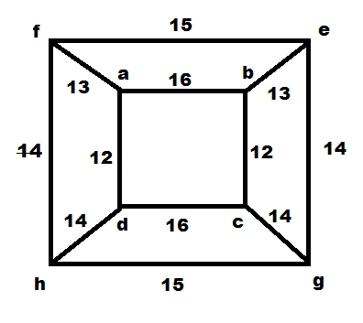

1. State Prim’s algorithm and apply it to compute the minimal spanning tree for following graph

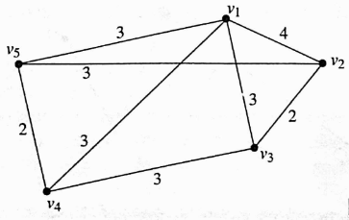

1. Using truth table, show that the statement formula $\sim (p∧q)⇆(\sim p∨\sim q)$ is a tautology.
2. Show that $r⇄s⟺\left(r∧s\right)∨\left(\sim r∧\sim s\right).$
3. Find the PDNF and PCNF of $(\sim p→r)∧(p⇆q)$ using truth table.
4. Represent the argument:

You study hard.

If you study hard, then you get A+

You get A+

Symbolically and find whether the argument is valid.

1. Represent the argument:

If it rains today, then we will not meet today.

If we do not meet today, then we will meet tomorrow.

If it rains today, then we will meet tomorrow.

Symbolically and find whether the argument is valid.

1. Represent the argument:

The integer is not divisible by 7.

If the integer is divisible by 21, then it divisible by 7.

The integer is not divisible by 21.

Symbolically and find whether the argument is valid.

1. Prove that the hypotheses ‘It is not sunny this afternoon and it is colder then yesterday’, ‘We will go swimming only if it is sunny’, ‘If we do not go swimming, then we will go to a museum’ and ‘If we go to a museum, then we will be home by sunset’ lead to the conclusion ‘We will be home by sunset’.
2. Symbolize the following statements:
3. Some dogs are black but all buffalos are black.
4. Sum of two positive integers is greater than both integers.
5. Every student in an Institution is either good in studies or good in sports.
6. Symbolize the following arguments using quantifier, variable, and predicates:

All healthy people eat fruit a day.

Soham does not eat fruit a day.

Soham is not a healthy boy.

Find whether the argument is valid.

1. Construct the truth table for $\left(p∧q\right)∨\left(q∧r\right)∨\left(r∧p\right).$
2. Prove the following equivalences:
$p→\left(q∨r\right)⇔\left(p→q\right)∨\left(p→r\right)$

$\left(p→q\right)∧\left(r→q\right)⇔\left(p∨r\right)→q$

$p→\left(q→p\right)⇔\sim p→\left(p→q\right)$

$\sim \left(p⇄q\right)⇔\left(p∨q\right)∧\sim \left(p∧q\right)$

$(\sim p∨q)∧\left(p∧\left(p∧q\right)\right)⇔p∧q$

$\sim p→\left(q→r\right)⇔q→(p∨r)$

3. Prove the following implications (without using truth tables):
$\left(\left(p∨\sim p\right)→q\right)→\left(\left(p∨\sim p\right)→r\right)⇒q→r$

4. $(p∨q)∧(p→r)∧(q→r)⇒r$.
5. Obtain the conjunctive normal forms of the following statement formulas:
$\left(q∨\left(p∧q\right)\right)∧\sim \left(\left(p∨r\right)∧q\right)$

$\left(p∧\sim \left(q∧r\right)\right)∨\left(p→q\right)$

6. Find the disjunctive normal forms ( DNF ) of the following propositions :
$\left(p∧\sim \left(q∨r\right)\right)∨\left(\left(\left(p∧q\right)∨\sim r\right)∧p\right)$

$p∨\left(\sim p→\left(q∨\left(q→\sim r\right)\right)\right)$

7. Prove that the hypotheses 'If you send me an e-mail message, then I will finish writing the research paper', 'If you do not send me an e-mail message, then I will go to sleep early' and If I go to sleep early, then I will wake up feeling refreshed' yield the conclusion 'If I do not finish writing the research paper, then I will wake up feeling refreshed'.
8. Express the negations of the following propositions:
9. If the teacher is absent then some students do not keep quiet.
10. The teacher is present and all the students keep quiet.
11. Some of the students do not keep quiet or the teacher is absent.
12. No one has solved every problem in the exercise.
13. Define isomorphic graph. Check whether the following graphs are isomorphic or not?

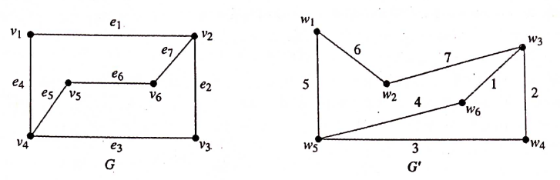

1. Explain Euler graph and Hamiltonian graph.
2. Apply Dijktra’s algorithm to find the out shortest path of the following graph $(a to f):$

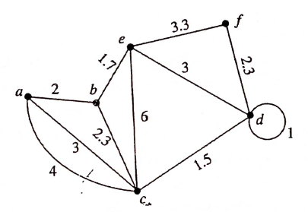

1. Prove that the number of vertices in a graph is always an even number.
2. Show that the number of edges in a simple graph having “n” vertices cannot exceed $n(n-1)/2$ edges.
3. Define bipartite graph. Construct the incidence matrix for the following di-graph

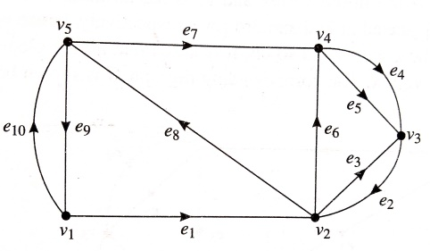

1. Define complete graph. Construct the adjacency matrix for the following di-graph

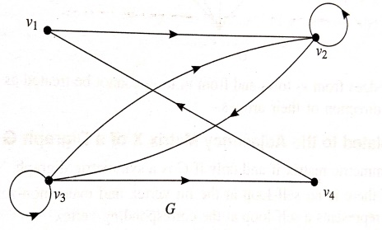

1. Define regular graph. Draw the graph for the following incidence matrix

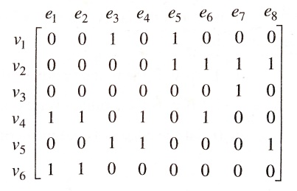

1. Define Planar graph. Draw the graph for the following adjacency matrix

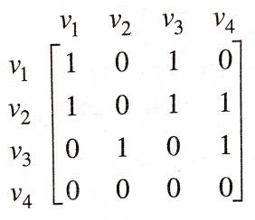

1. If a connected planar graph has $n$ vertices $, e$ edges $, f$ regions prove that $n-e+f=2$.
2. Suppose a connected simple planar graph has 20 vertices, each of degree 3. Into how many regions does a representation of this planar graph divide the plane?

Let G be a connected regular planar graph, the degree of each of its vertices being 3. Find the number of vertices of G if G has 20 regions.

1. Define Isomorphic graph, walk, Path, Circuit of a graph.
2. Examine whether the following two graphs are isomorphic or not?

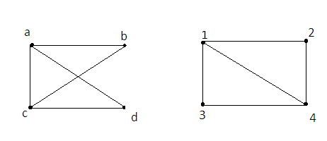

1. State the rules of kruskal’s Algorithm. Obtain minimal spanning tree of the following graph using Kruskal’s algorithm:

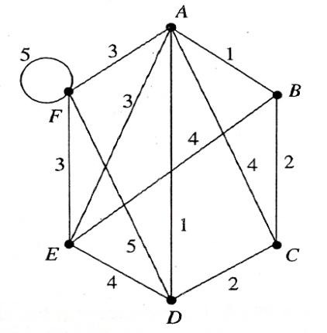

1. State the rules of Prim’s Algorithm. Obtain minimal spanning tree of the following graph

using Prim’s algorithm:

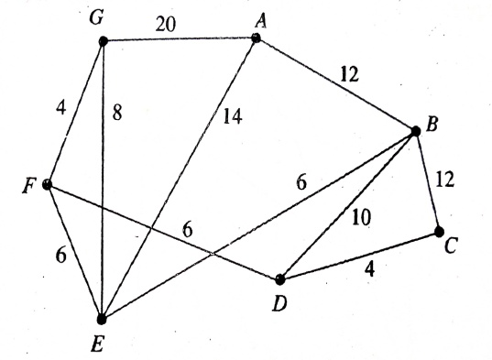

1. Using truth table, show that the statement formula $\sim (p∧q)⇆(\sim p∨\sim q)$ is a tautology.
2. Show that $r⇄s⟺\left(r∧s\right)∨\left(\sim r∧\sim s\right).$